Department of Computing

School of Electrical Engineering and Computer Science

CS-250: Data Structure and Algorithms
Class: BSAI 2A

Lab 1: Revisiting C++, Introduction to Version Control & Writing Test Cases in C++

Date: 09th September 2026
Time: 10:00 am – 12:50 pm

Instructor: Saud Kamran

Lab Engineer: Urooj Akmal

Lab 1: Revisiting C++, Introduction to Version Control & Writing Test Cases in C++

Introduction
This lab is about revising C++ programming concepts through moderately challenging problems that serve as a foundation for Data Structures and Algorithms (DSA). Students will also practice using GitHub and version control to manage their code. In C++, arrays, strings, and matrices are fundamental structures upon which advanced data structures are built. Students will implement modular functions in C++ and verify their correctness through systematic test cases.

Objectives
- Students will practice basic Git commands and use GitHub for version control.
- Students will revise and strengthen programming concepts learned in earlier courses.
- Students will practice modular programming by writing reusable C++ functions.
- Students will write systematic software tests for each implemented function.
- Students will prepare for advanced data structures by solving moderately difficult problems.

Tools/Software Requirement
- Visual Studio C++ (or any standard C++ IDE such as Code::Blocks, CLion, or g++ compiler).
- GitHub for version control and submission

Description
Students will begin by revising version control concepts using GitHub, followed by a series of C++ programming tasks. Each task emphasizes correct coding style, modularity, and testing. Students will commit their solutions to GitHub and submit their completed work on LMS in Word format.

Lab Tasks

Task 1 – GitHub Repository Setup (Step-by-Step)
Students will create and prepare a GitHub repository for this lab.

Create a new repository on GitHub
- Repository name: DSA-Lab1
- Visibility: Private or Public (as instructed).
- Initialize with: README.md
- Add a license: (optional) MIT
- Add .gitignore: C++ (students may refine later)

SCREENSHOT:
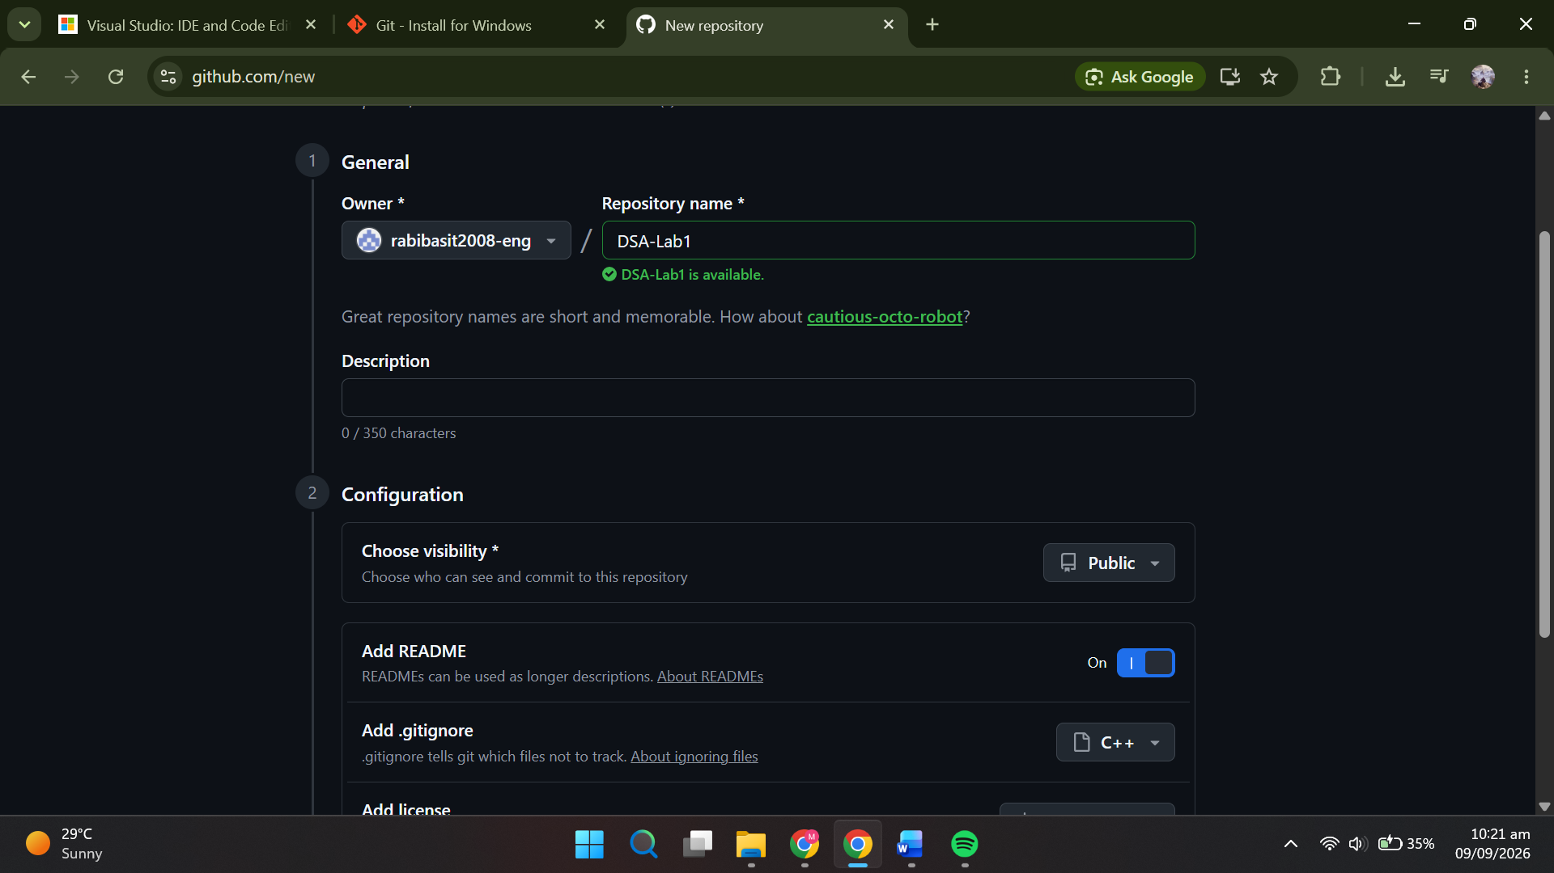


Clone the repository to a local machine
git clone https://github.com/<your-username>/DSA-Lab1.git
cd DSA-Lab1
Screenshot task 2:

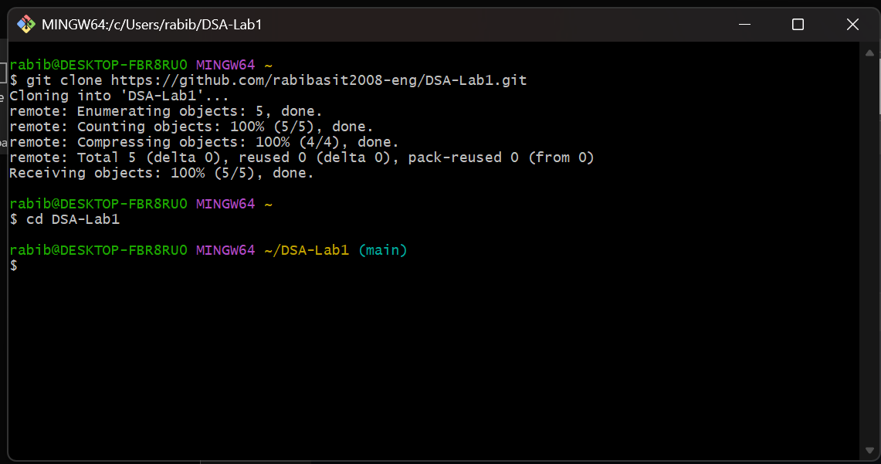

Set Git identity (first time only on a machine)
git config --global user.name "Your Name"
git config --global user.email "youremail@example.com"

Verify the remote
git remote -v
screenshot 3 & 4
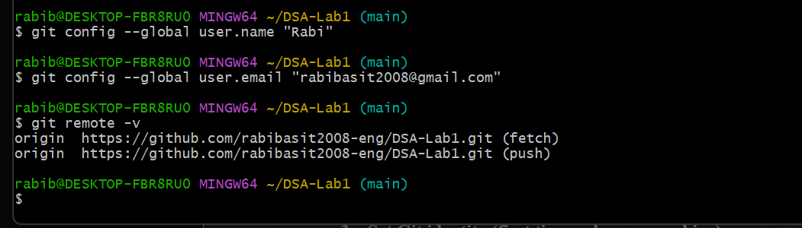
Remote lists all the repositories currently linked to your local project
Identity is your name and email address that git will attach to your commits, only need to setup once on a machine

Create a simple C++ starter file
#include <iostream>
using namespace std;

int main() {
cout << "Welcome to DSA Lab 1!" << endl;
return 0;
}

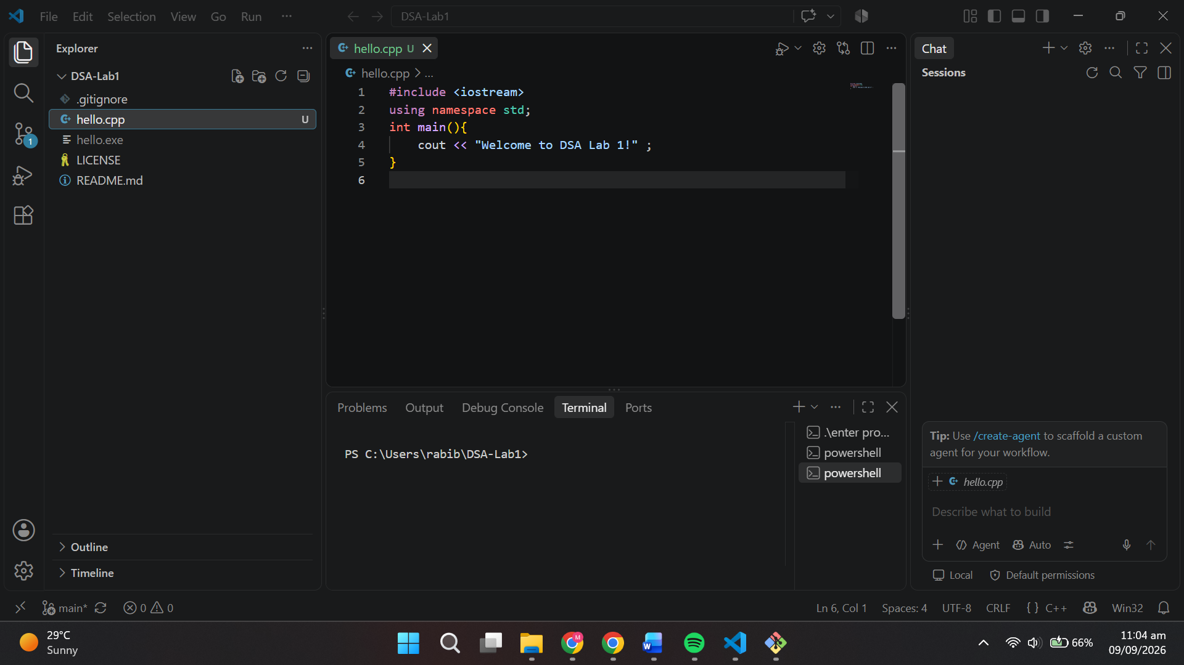

Build/run locally (example using g++)
g++ hello.cpp -o hello
./hello

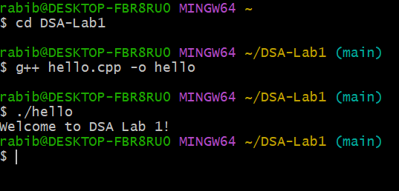

Stage, commit, and push
git status
git add hello.cpp
git commit -m "Add hello.cpp starter program"
git push origin main # If your default branch is master, use 'master'

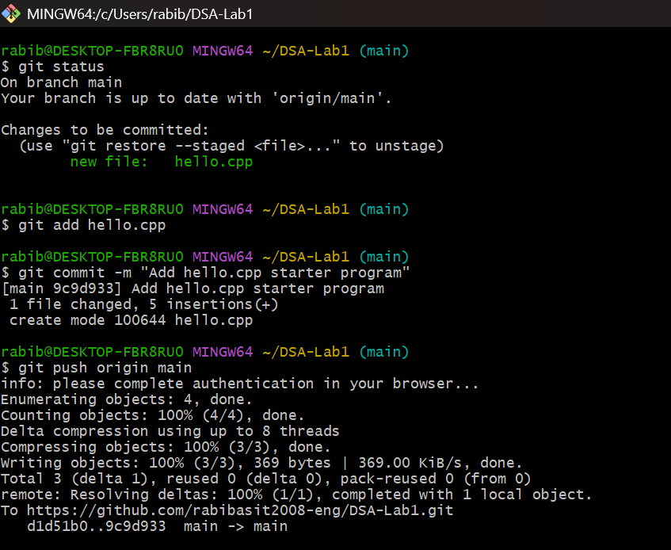

Students will refine .gitignore for C++/Visual Studio
# Build artifacts
*.o
*.obj
*.exe
*.pdb
/build/
/Debug/
/Release/

# IDE metadata (keep .sln and .vcxproj if instructed to submit them)
.vscode/
.idea/

git add .gitignore
git commit -m "Refine .gitignore for C++ build artifacts"
git push

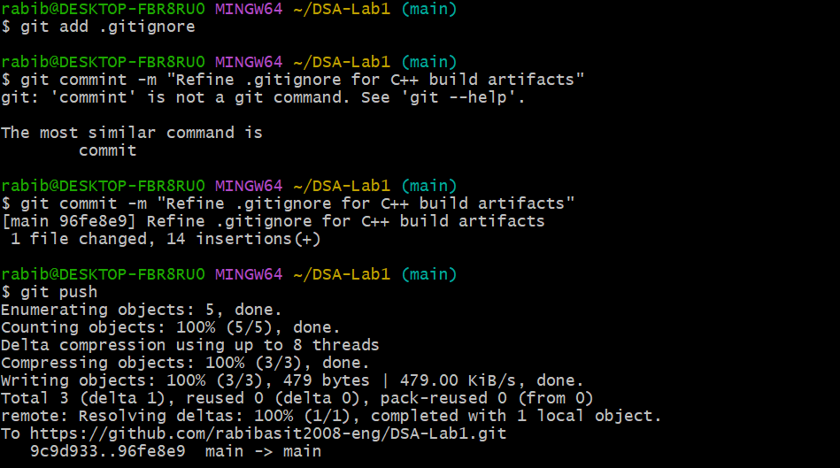
Modified gitignore and committed the changes after which u push it to main repo

Confirm History
git log --oneline --graph --decorate --all

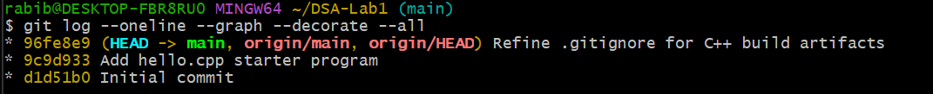
Task 2 – Git Workflow Practice (Branch → Implement → PR → Merge)

Create and switch to a feature branch
git checkout -b lab-tasks

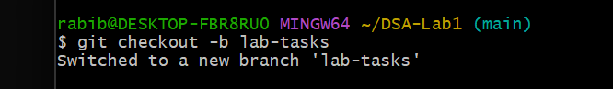

Add module files
  - Create utilities.h:
#ifndef UTILITIES_H
#define UTILITIES_H

int add(int a, int b); // placeholder example

#endif
  - Create utilities.cpp:
#include "utilities.h"
int add(int a, int b) { return a + b; }

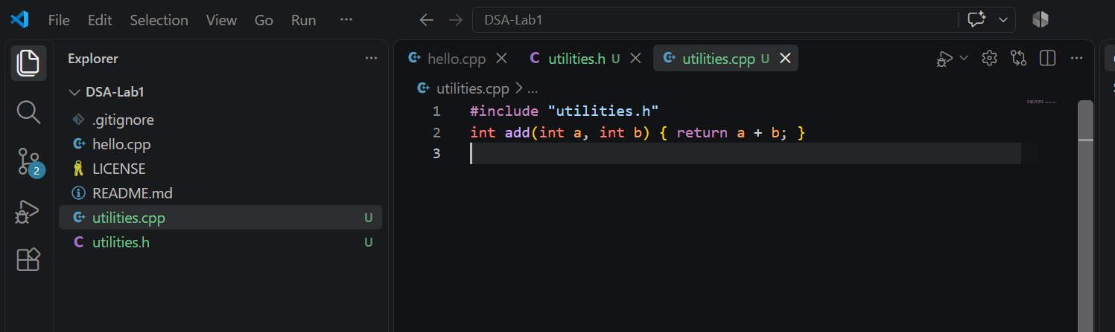
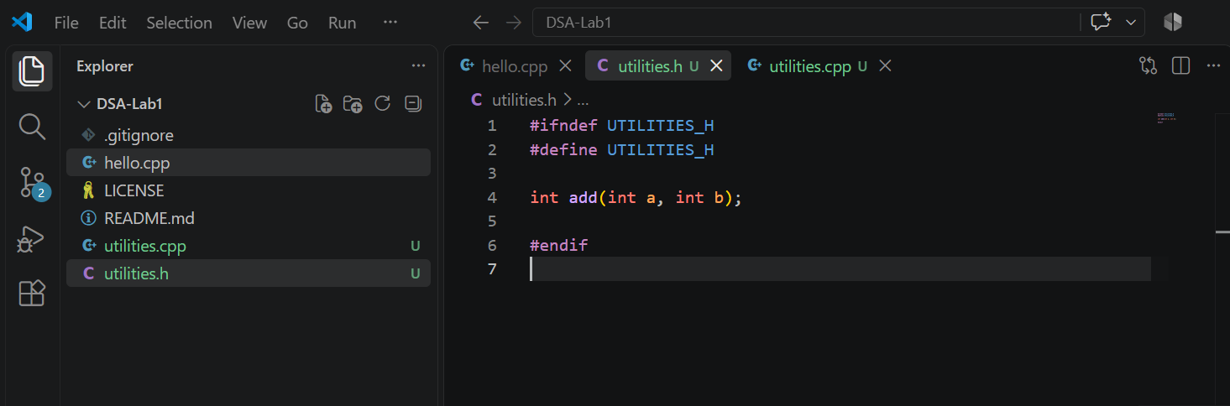

Add a quick test driver (temporary, will be replaced by full test file later)
File: test_utilities.cpp
#include <iostream>
#include "utilities.h"
using namespace std;

int main() {
cout << "add(2,3) == 5: " << (add(2,3) == 5 ? "PASS" : "FAIL") << endl;
return 0;
}

g++ utilities.cpp test_utilities.cpp -o test_utilities
./test_utilities

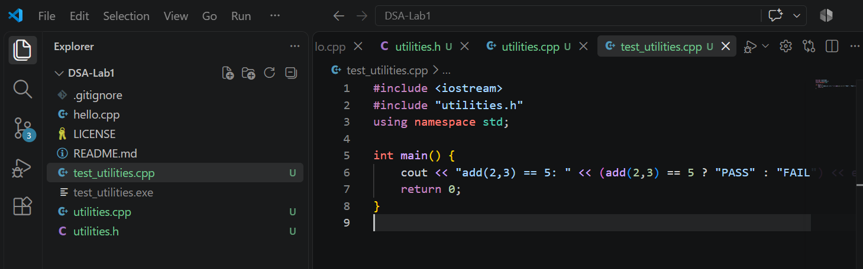
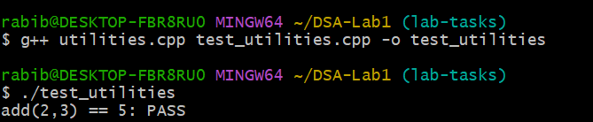

Stage and commit incrementally
git add utilities.h utilities.cpp
git commit -m "Add utilities module with add(a,b)"
git add test_utilities.cpp
git commit -m "Add smoke test for utilities::add"

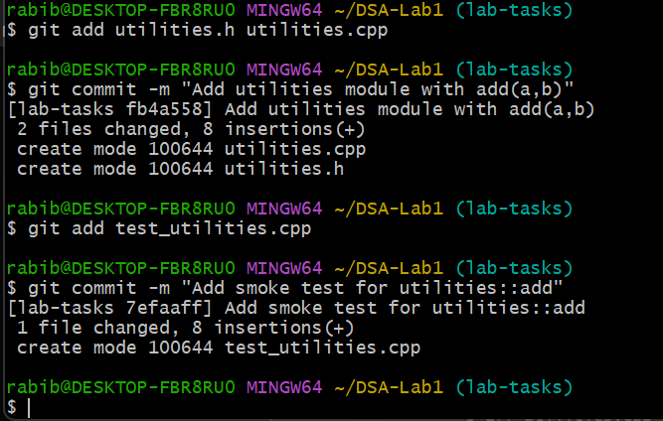

Push the branch and create a PR
git push -u origin lab-tasks
- On GitHub: Open Pull Request → compare lab-tasks into main.
- Add a clear PR title & description (what changed, why, how tested).
- Request a review (peer or instructor as applicable).
- Make changes locally->commit->push

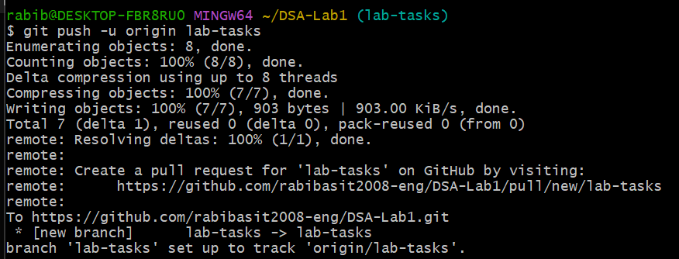
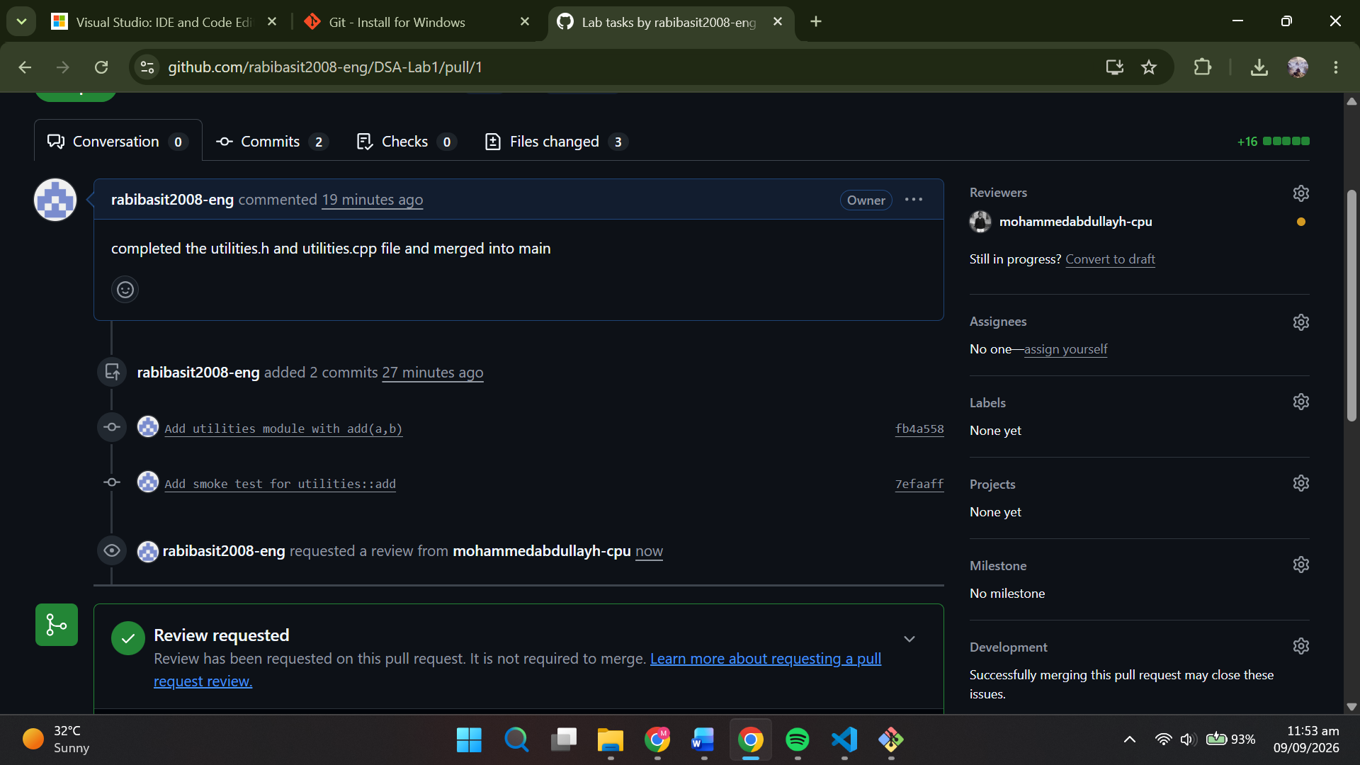
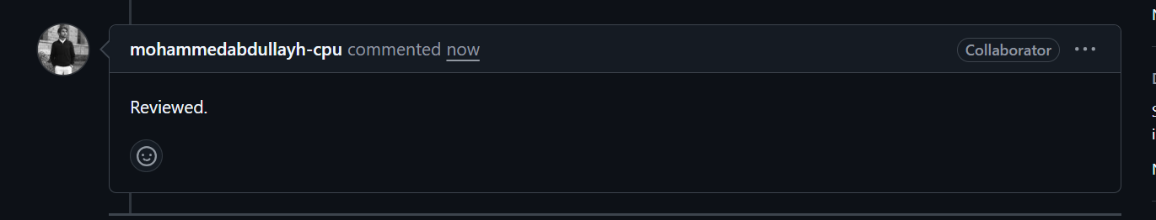

Merge the PR
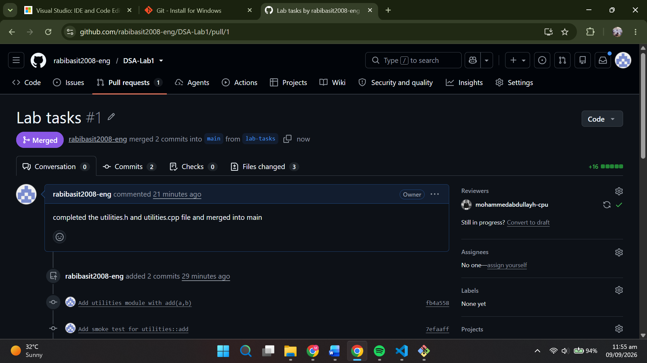
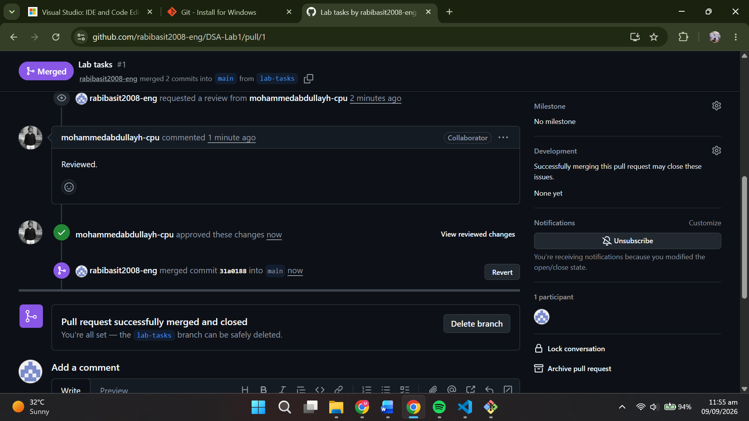
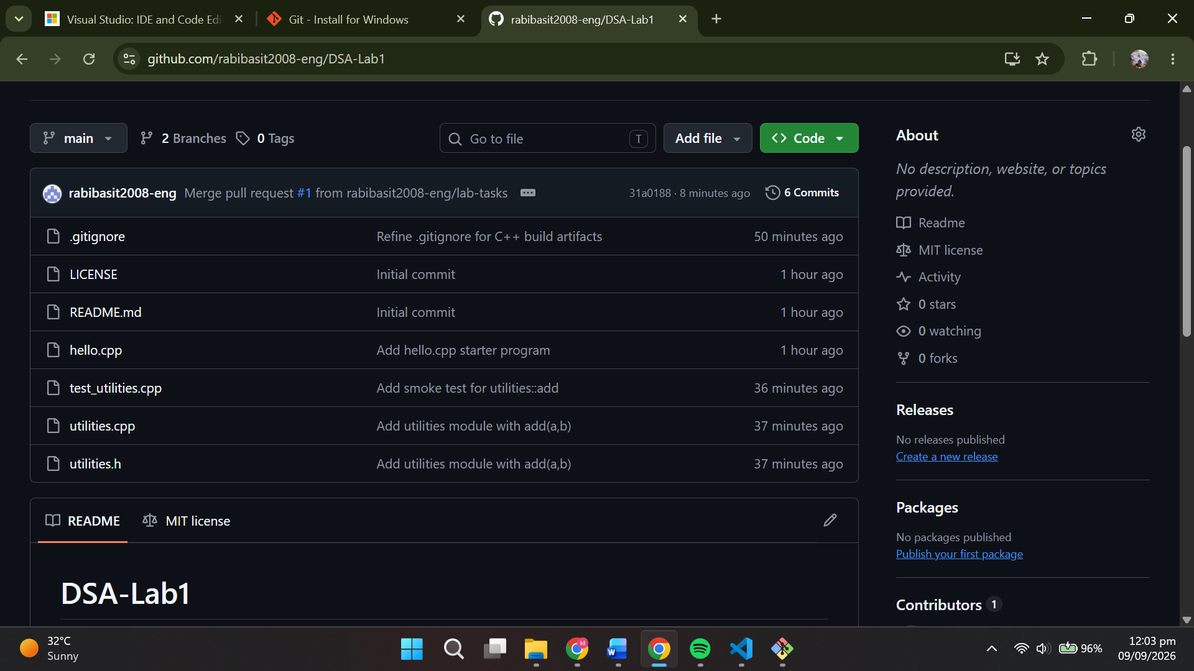

Sync the local main
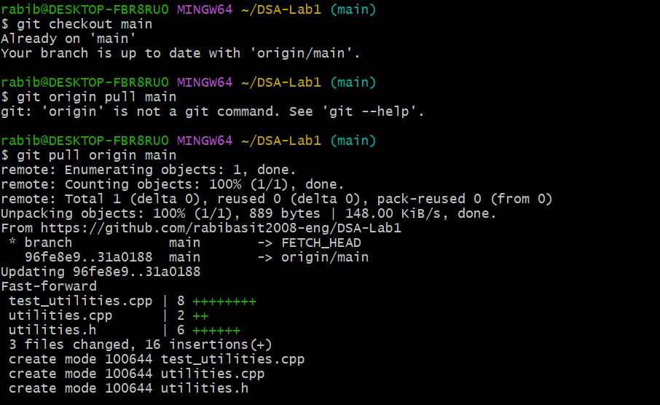

Simulate a simple merge conflict
  - On GitHub: edit README.md in main (add a new line).
  - Locally on a new branch, edit the same line in README.md, commit, and push.
  - Open a PR; GitHub will show a conflict.
  - Students will resolve via the GitHub conflict editor or locally:
git fetch origin
git checkout lab-tasks
git merge origin/main # triggers conflict locally
# Edit the conflicted files to keep the correct content
git add README.md
git commit # completes the merge
git push # PR becomes mergeable

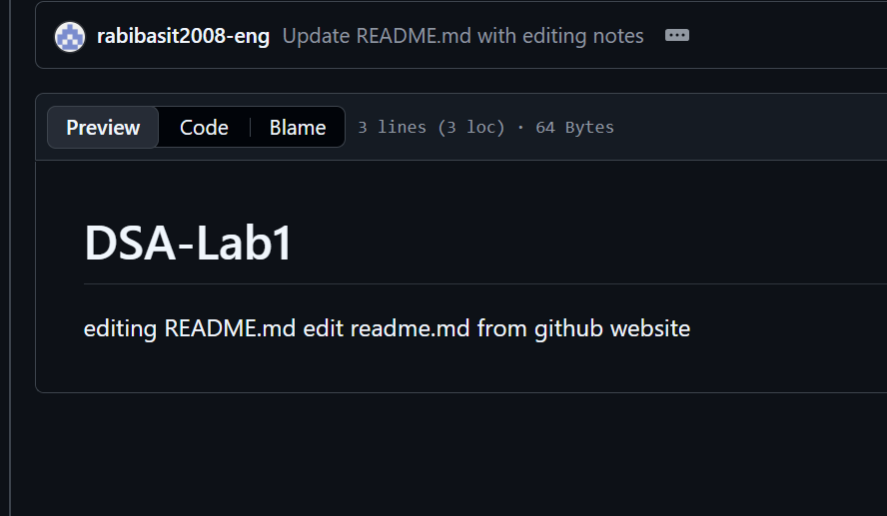

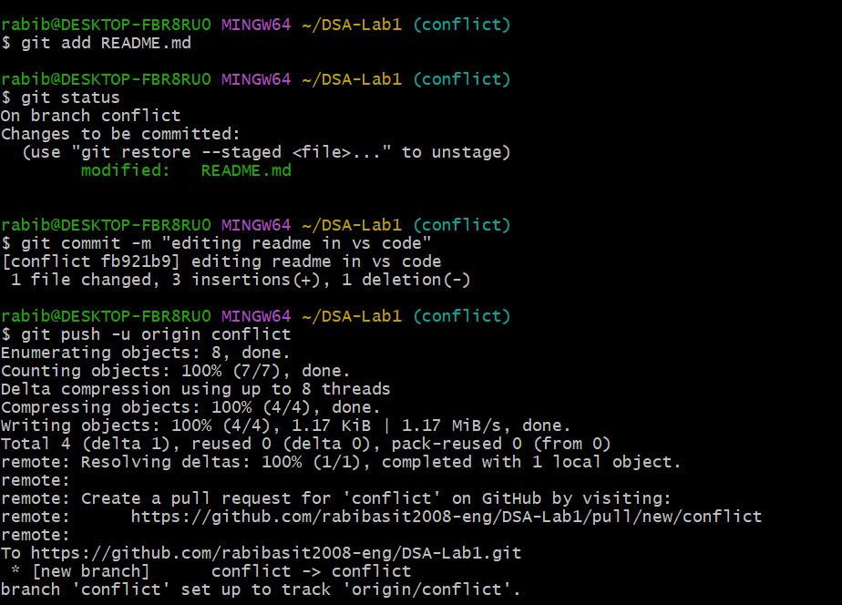

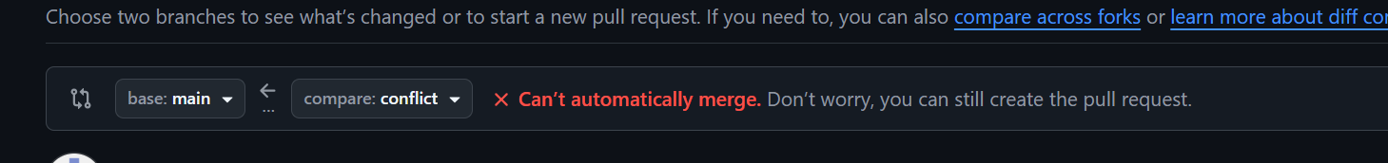
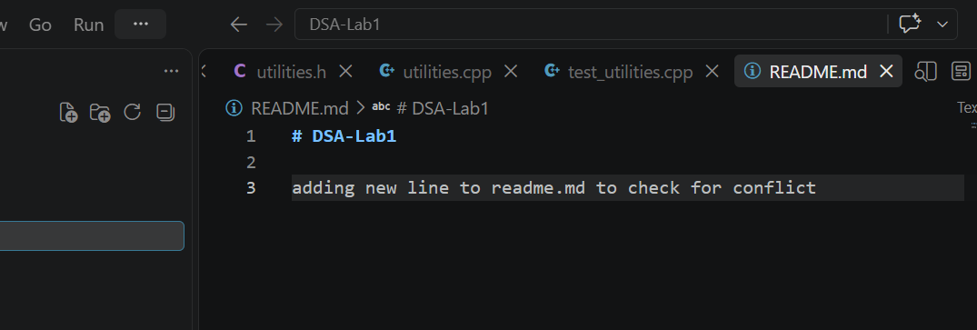

Conflict arises when we tried to merge both of the readmes as github does not merge it so conflict.
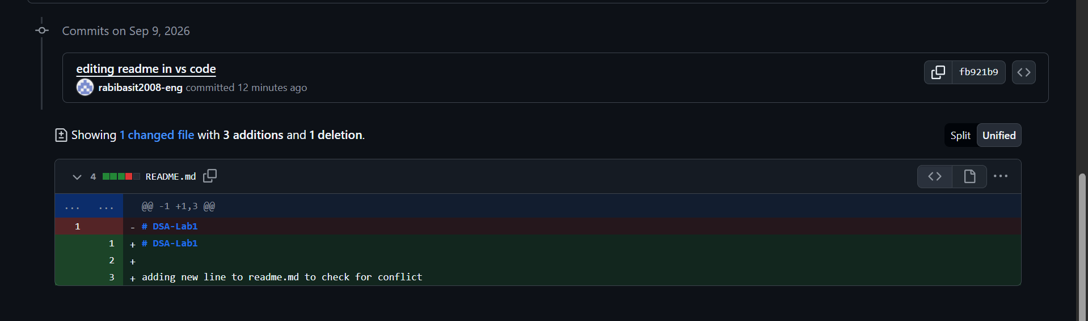

Task 3 - Find All Indices of an Element
Write a function that finds all indices of a given element in an array.
- Input: Array and a key.
- Output: Vector of indices.
- Test cases:
  - Multiple occurrences.
  - Key not present.
  - Empty array.

Task 4 – String Pattern Matching (Naive Algorithm)
Write a function that finds the first occurrence of a substring (pattern) in a given text. If not found, the function will return -1.
- Test cases:
  - Pattern at the beginning.
  - Pattern at the end.
  - Pattern not present.
  - Empty pattern.

Task 5 – Pascal’s Triangle
Write a function that generates Pascal’s Triangle up to n rows.
- Test cases:
  - n = 0, n = 1, n = 5.
  - Verify row 5 → {1, 4, 6, 4, 1}.

Task 6 – Histogram Analysis (Mode of Array)
Write a function that returns the mode (most frequent element) in an array.
- Test cases:
  - Array with unique mode.
  - Array with multiple modes.
  - Empty array.

Task 7 –Strassen’s Matrix Multiplication
Implement Strassen’s Algorithm for multiplying two square matrices (size$2^{n}×2^{n}$). Compare the result with the standard matrix multiplication algorithm.
- Test cases:
  - 2×2 matrix multiplication.
  - 4×4 matrix multiplication.
  - Random values compared with naive multiplication.

Source files attached.
Github link:

https://github.com/rabibasit2008-eng/DSA-Lab1

Deliverables
- A single Word document containing:
  - Steps of execution of Task 1 & 2 with screenshots
  - GitHub Repo link (must remain public till final grades are posted)
    - The repo should contain all the source files
- A zip file containing the following for each of Task 3-7
  - A source code file, containing the implementation for the task
  - A source code file, containing the test cases and main method pertaining to the task
- Students must submit both files on LMS before the deadline.
- File naming convention: YourFullName(Reg#)_Lab1
Use proper indentation and comments. Lack of comments and indentation will result in deduction of marks.

Lab Rubrics
Assessment | Doesn’t meet Expectation (1–2) | Meets Expectation (3–4) | Exceeds Expectation (5)
Software Problem Realization (CLO2 – PLO2) | The student is unable to outline the problem or use relevant methods. | The student needs guidance to comprehend the problem and identify a suitable method. | The student fully understands the problem, analyzes methods, and develops program flow.
Software Tool Usage (CLO3 – PLO5) | The student shows no command over IDE or Git, code is incomplete or with syntax errors. | The student demonstrates limited command, code compiles but output is inconsistent. | The student demonstrates full command, writes correct and functional code, and manipulates Git tools effectively.
Ethics and Adherence to Lab Rules (CLO4 – PLO8) | The student ignores ethical norms, disrupts lab, careless about safety/punctuality. | The student partially follows ethical norms, shows improved behavior and punctuality. | The student fully adheres to professional ethics, is punctual, and encourages peers to follow lab decorum.

